S&P500 Futures

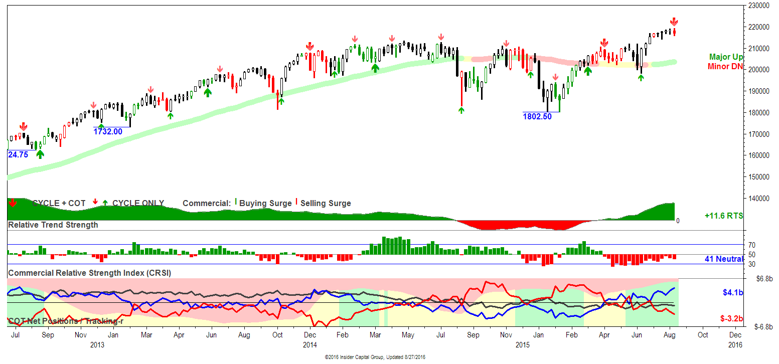

NASDAQ Futures

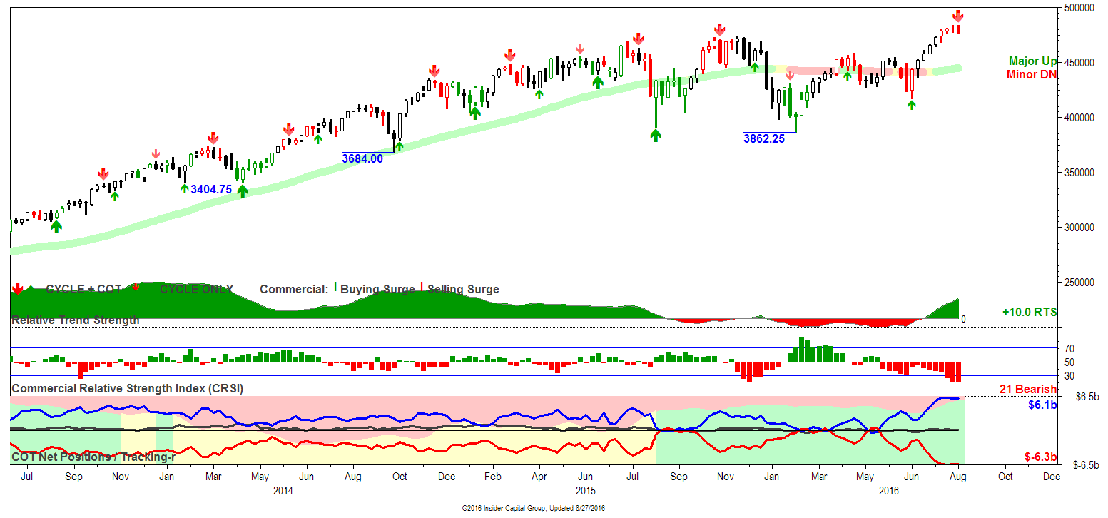

NASDAQ E-MINI: Commercials were net sellers on an up week through Tuesday's COT tabulation, and...*A new COT sell signal was posted along with a trading cycle high. A move above 4836.75 this week would cancel the COT signal arrow. *The fund near-record notional extreme with a similar commercial net short total creates conditions ripe for a significant pullback. A technical weekly bearish reversal bar was posted, favoring a downside follow-through this week.

Dow E-Mini Futures

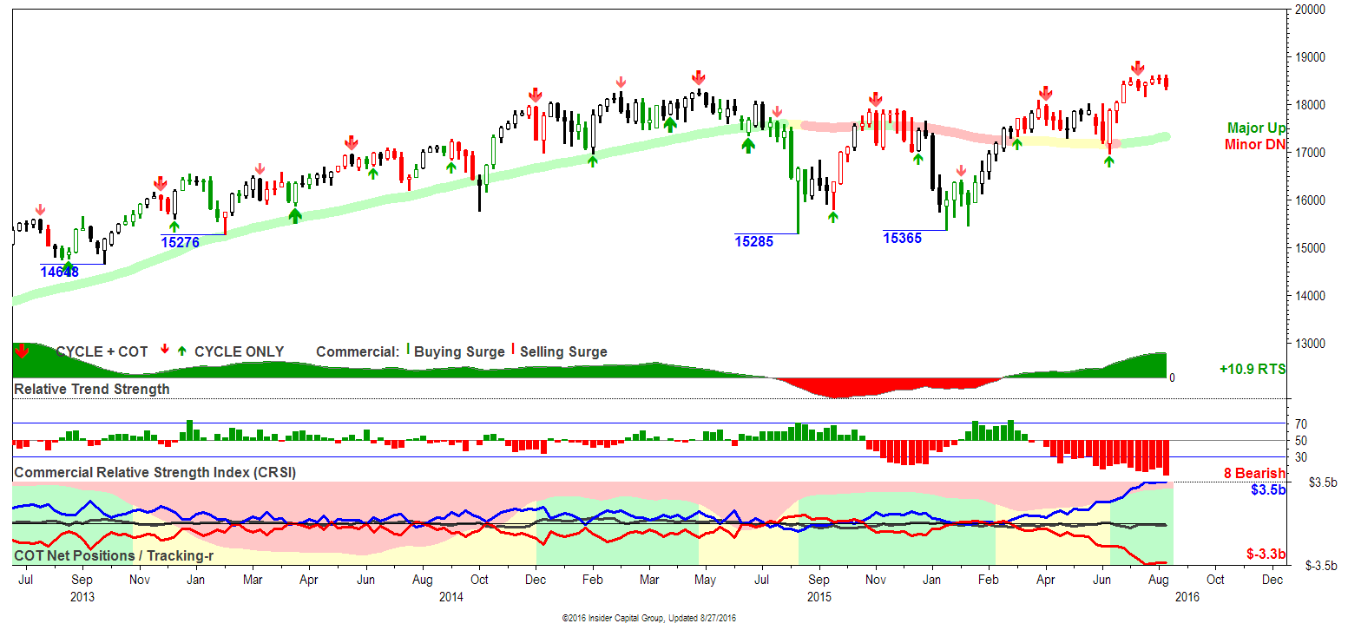

Russell 2000 Futures

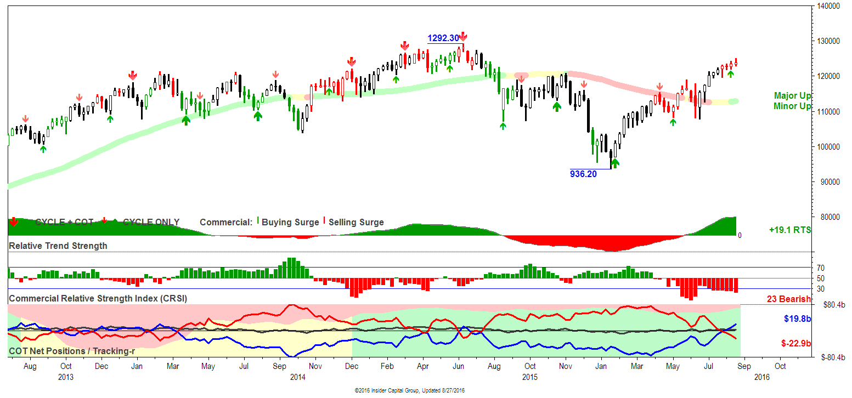

RUSSELL 2000: Commercial selling surged $67.8b in futures and options over the past seven weeks, marked by four consecutive red price bars. The most recent COT signal was a buy several months ago, which is now expired. *Funds set an all-time record long-only position, suggesting high risk of an eminent upside reversal. Technicals are bullish, with a positive RTS corroborating minor and major bull trends. COT sell signals in other sector markets apply here

Gold Futures
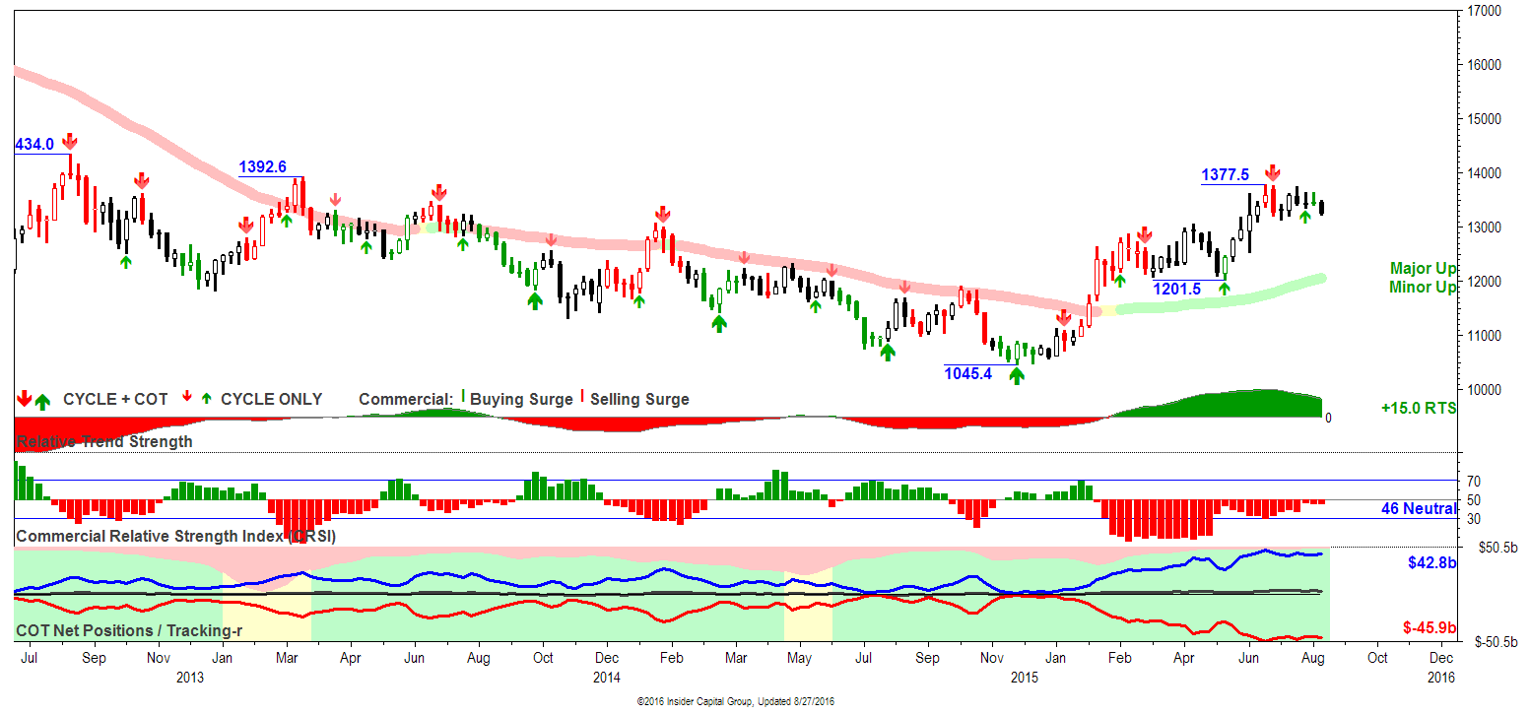

Silver Futures

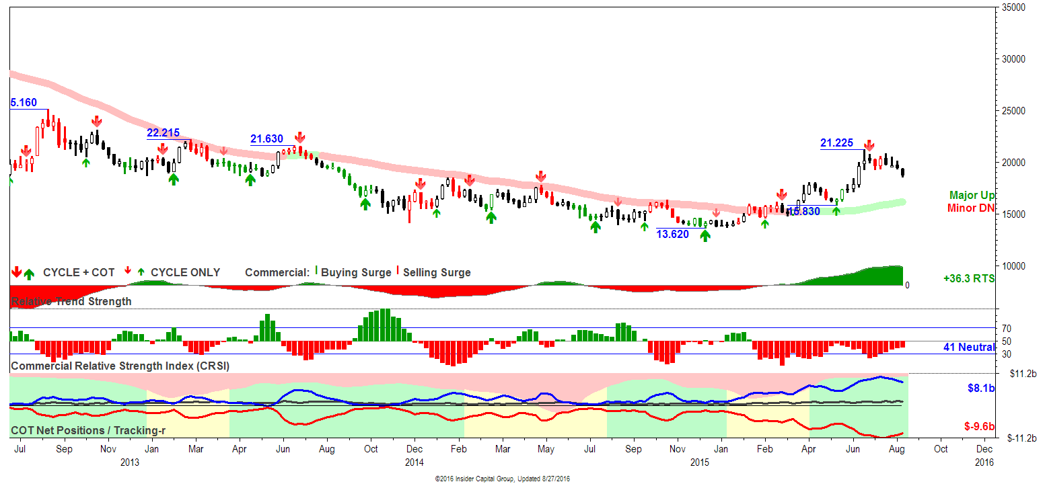

Crude Oil

CRUDE OIL: The two large trader groups both produced weekly trading surges, funds buying totaling $2.2b and commercials selling 2.6b. This placed total commercial sales at the 76 percentile and fund buys at the 95 percentile of historic weekly totals, and...*A new COT sell signal was posted along with a trading cycle high. *Funds hold a near-record long oly position extreme, creating huge long lquidation risk. This week's price action formed an inside bar, adding to potential trader interest in next week's price trend.

Because of the rapid decline in oil prices, Saudi Arabia – one of the largest oil-producing members of OPEC – says it will once again talk about cutting production. And Iran says it might even attend the OPEC meeting this time...
We already know how this story will end, though.
We've seen this story play out twice already this year... back in February, when Saudi Arabia first announced talks of a production freeze... and again in April, when the OPEC countries met in Qatar and came away with nothing.
The same thing will happen this time because of one key factor: Iran is still a member of OPEC. As we've told you before, the relationship between Saudi Arabia and Iran is terrible, and Iran isn't about to agree to restrict oil production right now after 35 years of sanctions.
So even if the Iranians attend the meeting (they bailed out of the last one), the oil-supply situation isn't going to change.
Remember, this is all about market share. Saudi Arabia wants to keep the Asian markets to itself. It is competing with cheap oil from Russia. It's also troubled by new production coming from post-sanction Iran.
So Saudi Arabia opened its spigots all the way. It produced close to 11 million barrels per day in July... and then talked about freezing production. In other words, it produced as much oil as it could before saying, "We won't go any further."
Saudi Arabia produced a huge volume of oil last month... and it offset a lot of the production decline in the U.S. That's part of the reason why oil prices fell recently.
Oil prices are going to move like this for the next few months. We're in for a rough ride. Until Saudi Arabia, Russia, Iran, and the rest of OPEC quit flooding the market with oil, volatility is here to stay.

While production declines in the US are bullish, the Baker Hughes jump in Rig Count suggest that decline may reverse or at least moderate. That viewed in connection with global political situation and the large long fund position in futures and options suggest that there is still quite a bit of risk on the downside in oil.

If and when we see some selling capitulation in Fund long positions, there may still be more risk to the downside in oil.

One other factor that seems to be bearish Oil. on Friday, the US Dollar had an BULLISH OUTSIDE UP DAY and the Euro had a BEARISH OUTSIDE DOWN DAY. This on the back of Janet Yellen, Fed Chairman's very hawkish speech. This may be the kick off of a final dollar rally to new highs. This would be bearish all commodities, and would set the stage for an exceptional buying opportunity. The Dollar is overdue to complete its 16-year Cycle (peak to trough and back to peak; last dollar peak was in 2000) in this year (was supposed to be Summer, so perhaps the top is in; though it doesn't appear so). The pattern in the dollar chart suggests that since the March 2015 dollar top, the Dollar has been in countertrend triangle pattern. That potential 4th wave triangle pattern could be considered complete, setting the stage for a final dollar Rally above 101, now at 95.69.

EUR/USD 4, 8, and 16 year cycles chart:

